Guide for Adult renewal application (PC7) by mail
 | Complete your renewal application form online  - The application must be lodged within six months of completion
 | Print and sign your application form  - Print on plain white A4 paper, using blank ink only. Make sure the top or bottom of the page is not cut off.  - US standard letter paper or US legal paper sizes are also acceptable, but only if they’re scaled properly. Refer to more information on printing your application form  - Sign the form using black pen, within the signature box. Make sure there are no alterations or whiteout on the signature or the date.
 | 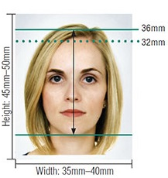  Photos  - Two recent identical colour photos, less than 6 months old with your full name written on the back of one photo. Refer to photo guidelines for more information  - Do NOT attach the photos to the form as this may damage them
 | Payment  - Please contact the Australian High Commission in Port Vila for payment process  - You can view more information on passport fees https://vanuatu.embassy.gov.au/files/pvla/Fees%20June%202022.pdf
 | Check your adult renewal checklist  - Before posting your application, review your adult renewal checklist [link to PDF]
 | Post your application  Australian High Commission  Po Box 111  Port VilaVanuatu
 | How long will it take?  - Please allow a minimum of eight weeks to receive a new passport once payment has been taken. PLEASE NOTE incomplete applications will cause delays.

